* **Patent** is a monopoly grant and it enables the inventor to control the output and within the limits set by demand, the price of the patented products. Patent is the product and patentee is the inventor.

The creative work of the human mind is protected through several measures and the main motivation for the same is that such protection is a definite measure of encouragement for the creative activity.

* The origin of the Indian Patent System could be traced to the Act of 1856 granting exclusive privileges to inventors. The patent regime at the time of Independence was governed by the **Patents and Designs Act, 1911**, which had provisions both for product and process patents. The way the Act was designed benefited foreigners far more than Indians.  
  Based on the committee’s recommendations, the **1911** Act was amended in 1950 (by Act XXXII of 1950) in relation to working of inventions, including compulsory licensing and revocation of patents.  
  In **1952**, a further amendment was made (by Act LXX of 1952) to provide for compulsory license in respect of food and medicines, insecticide, germicide or fungicide, and a process for producing substance or any invention relating to surgical or curative devices.

In 1957, Justice Ayyangar’s report specially discussed (**a) patents for chemical inventions; and (b) patents for inventions relating to food and medicine**. **The Patents Act, 1970, came to be enacted** mainly based on the recommendations of the Justice Ayyanger’s report, and came into force **on April 20, 1972 replacing the Patents and Designs Act, 1911**.

* **Patents act 1970**

The Patents Act, 1970 remained in force for about 24 years without any change till December 1994.  
the basic philosophy of the Act is that patents are granted to encourage inventions and to secure these inventions. Patents are granted not merely to enable patentee to enjoy a monopoly for the importation of the patented article into the country.  
  
**Allowed to be patented:** are the patents for food, medicine or drug, pesticides and substances produced by chemical processes which, apart from chemical substances normally understood, also include items such as alloys, optical glass, semi-conductors, inter metallic compounds etc.  
**Not allowed to be patented:** products vital for our economy such as agriculture & horticulture products, atomic energy inventions and all living things are not patentable

**First amendment** of the patent act in **1999**: The amended Act provided for filing of applications for product patents in the areas of drugs, pharmaceuticals and agro chemicals.

**Second amendment** of the patent act in **2002**: increasing the term of patent to 20 years for all technology, Reversal of burden of proof, compulsory licenses etc.

The **third** **amendment** to the Patents Act 1970 was introduced through the Patents (Amendment) Ordinance, **2005** incorporating provisions for granting product patent in all fields of Technology including chemicals, food, drugs & agrochemicals

There are **four Schedules to the Patents (Amendment) Rules 2005**;

**First Schedule** prescribes the fees to be paid;

**Second Schedule** specifies the list of forms and the texts of various forms required in connection with various activities under the Patents Act. These forms are to be used wherever required and if needed, they can be modified with the consent of the Controller.

**Third Schedule** prescribes form of Patent to be issued on Grant of the Patent.

**Fourth Schedule** prescribes costs to be awarded in various proceedings before the Controller under the Act.

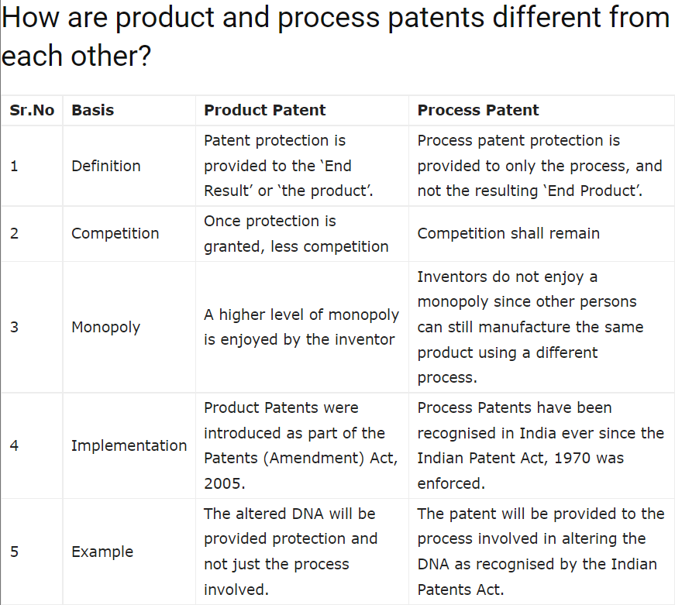

* **Duration of patents**

Every patent granted after the commencement of the patents act 2002 and which have not expired, will have a **term of twenty years from the date of filing of patent application**.  
Also term of patent in case **of international applications** filed under the PCT designating India, **shall be twenty years from the international filing date**.

A patent shall cease to have effect on the expiration of the period prescribed for the payment of any renewal fee, further the subject matter covered by the said patent shall not be entitled to any protection.

Rule 80 requires that to keep a patent in force, the renewal fees specified in the First Schedule should be paid at the expiration of the second year from the date of the patent or of any succeeding year. Patents (Amendment) Rules, 2005 provides that the period for payment of renewal fees may be extended by not more than six months on request in Form 4.

* **Elements of Patentability**

The principal therefore, is that every simple invention that is claimed, so long as it is something which is novel or new, it would be an invention and the claims and specifications have to be read in that light. The patent must be in respect of an invention and not a discovery.  
“New invention” is defined as any invention or technology which has not been anticipated by publication in any document or used in the country or elsewhere in the world before the date of filing of patent application.

Therefore, the conditions of patentability are:

• **Novelty**

A novel invention is the one which is completely new and not disclosed in any prior arts.  
An invention shall not be considered to be novel :

* If it has been anticipated by publication before the date of the filing of the application, on or after 1st January 1912 in India.
* If it has been anticipated by publication made before the date of filing of the application in any of the documents in any country.
* If it has been claimed in any claim of any other complete specification filed in India.
* if it has been anticipated having regard to the knowledge, oral…. within any local or indigenous community in India or elsewhere.

**• Inventive step (non-obviousness) and**

Inventive step is a feature of an invention that involves technical advance as compared to existing knowledge or having economic significance or both, making the invention non obvious to a person skilled in art.

**• Industrial applicability (utility)**

An invention is capable of industrial application if it satisfies three conditions, cumulatively:

* can be made;
* can be used in at least one field of activity;
* can be reproduced with the same characteristics as many times as necessary